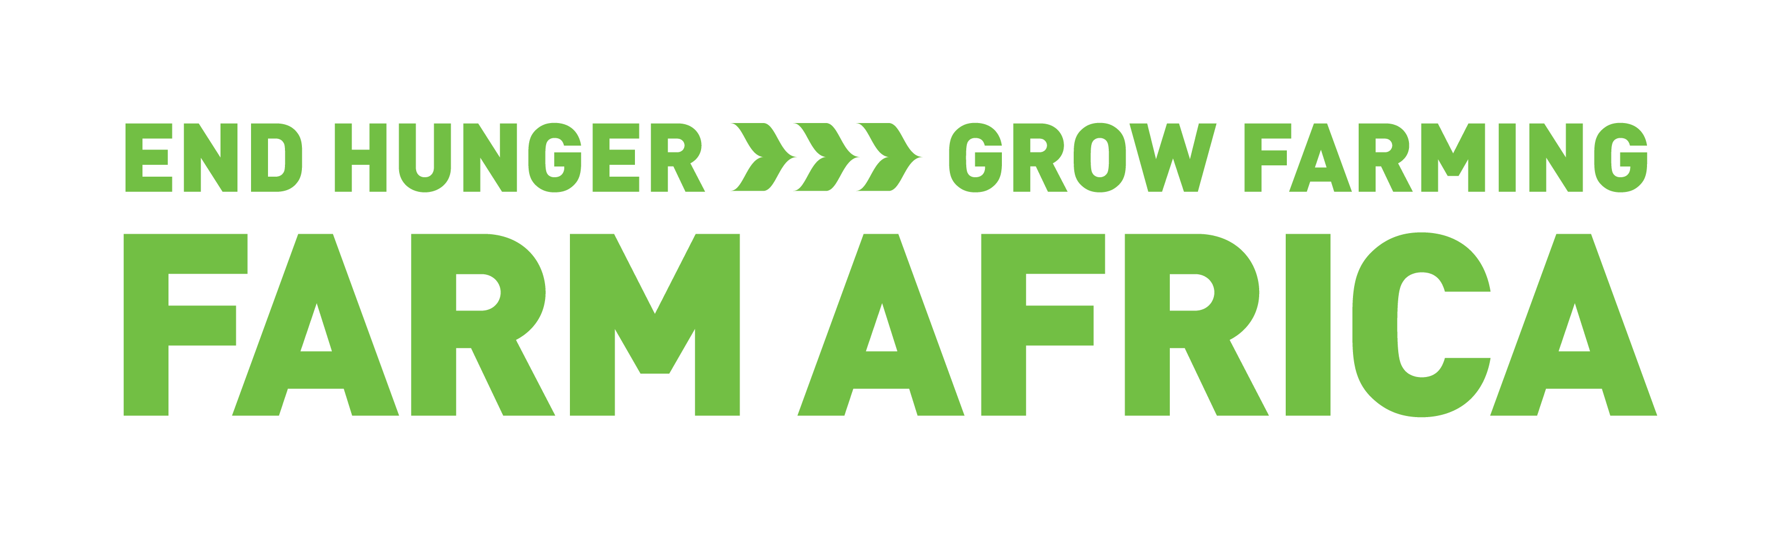
MAENDELEO AGRICULTURAL ENTERPRISE FUND (MAEF)

CONCEPT NOTE TEMPLATE

A | Organization/ Implementing agency contact details
1 | Organisation (Business) Name
2 | Postal Address
3 | Physical Address
4 | Contact Telephone Number
5 | Organisation email address
6 | Organisation website

B | Contacts of Business Lead
1 | Names of contact person
2 | Job Title
3 | Email address
4 | Mobile Number

C | Business Entity Details
1 | Type of company/ Organisation
2 | Registration Number/ Status
3 | Business Idea Title
4 | Business location  (Country, Region, District)
5 | Main commodity or products
6 | Start Date: | End Date:

D | Financial Details
Funds requested for your business idea |  |  |  | GBP (£)
1 | Grant Requested from MAEF (GBP (£))
2 | Contribution from your business / or individual(GBP (£))
3 | Project Total (GBP (£))
4 | List Other Donors / Financiers, | Amount | Year of support | Amounts (Indicate their currency)
a
b
c
d
5. | Describe your financial management systems including, financial monitoring / tracking, reporting and controls (100 words)

E | Describe your Business Idea: Include 3 key objectives of your business idea ( maximum 250 words)

F | What is the rationale or justification of your business idea? Why do you think the business will succeed? Describe how your business idea will be profitable (maximum 200 words)

G | Viability of your Enterprise ( in GBP (£))
 | Level of Business | Transaction |  | Current level/ yr | Projected level/ yr  In the 11/2 years
I | Farm level | Production cost acre | a
I | Farm level | Total output per acre in kg | b
I | Farm level | Selling price per kg | c
I | Farm level | Gross Income | d=bxc
I | Farm level | Gross margin as a % | ((d-a)/a) * 100
II | Institutional level/ Business entity | Production cost per unit | a
II | Institutional level/ Business entity | Total output | b
II | Institutional level/ Business entity | Selling price per unit | c
II | Institutional level/ Business entity | Gross Income | d=bxc
II | Institutional level/ Business entity | Gross margin as a % | ((d-a)/a)* 100

H | What is the capacity of your business to implement the idea? What resources do you have that will assist the business achieve its long term goals? (maximum 200 words)

I | Describe the partners who will assist you implement your business idea clearly explaining the linkages and specific roles of each partner (maximum 200 words)

J | Describe what is innovative about your business Idea that will ensure successful adoption? (maximum 300 words)

K | What is the expected social and economic impact of your business idea? How will you empower small scale farmers? How will the business affect equity in the target households/communities. How many direct and indirect households will benefit? (maximum 200 words)

L | Describe how your business idea will lead to improved resilience to climate change among the poor and vulnerable communities in the proposed business location. (maximum 200 words)

M | How would you organise your marketing system? Briefly describe the target market explaining the demand and supply aspect of the commodities that your business will handle. What is the size of the market? (maximum 300 words)

N | Describe what impact your business idea will have on other businesses in your value chain  (maximum 200 words)

O | Financial Details Breakdown: Reference to section D, show how the funds will be utilized to enable your business operate successfully
Cost centers (e.g. capacity building, marketing, equipments etc) |  | GBP (£)
1
2
3
4
5
 | Project Grand total
(Note: the Project Grand totals for section O must equal to the Project Grand totals for section D)

P | Explain how this grant will ensure full commercial sustainability of the business or business entity beyond grant period (maximum 200 words)

Q | Describe any positive and / or negative social and environmental impact that your business will create in the proposed location stating how you will deal with negative impacts (if any). (maximum 200 words)

R | What are the potential social and economic sustainability, scaling-up and replication aspects of the business in other areas? (maximum 200 words)

S | What mechanisms will you put in place to ensure effective monitoring and evaluation of your business once established? (maximum 200 words)

T | Describe what risks your business idea might face? Explain how you plan to mitigate these risks.  (maximum 200 words)

